Tips for using the 2005 Wake County Orthos

Using an Image Catalog in ArcMap p.2
ArcMap HELP: The Color Orthos are Black & White! p.3
Layer file for Planning Jurisdictions (.lyr) p.4
Viewing MrSIDS in ArcView 3.x p.5

Using an Image Catalog in ArcMap

An Image Catalog is a .dbf file that can be added to ArcMap to bring in a group of images at once.

***If you are NOT using ArcGIS you can ignore/delete the image catalogs (.dbf files).
***If you are using ArcMap you do not have to use the Image Catalogs. You can add the orthos to ArcMap individually if you prefer.

If you would like to use the Image Catalogs:
1. In order to use the Image Catalogs you can either
a) Copy the images from the DVDs to the following file structure: C:\gis\orthosbw2005 and C:\gis\orthoscolor2005

OR
b) Copy the images somewhere else. If you do choose this option, you will need to open the Image Catalog in Excel – do a find and replace on the file path – save as a .dbf

Once you have the Image Catalogs & orthos on your local drive:
2. Open ArcMap
3. Click the Add Data button (or File - Add Data)
4. Navigate to the Image Catalog:
2005_color_compr_image_catalog.dbf
or
2005_bw_compr_image_catalog.dbf
5. Click OK.

6. You will see a wireframe of the County. The Orthophotography will show up when you are zoomed in.

7. To change the extent at which the orthos show:
Right-click on the layer in the Table of Contents - Properties
Display Tab - Change the number in "Display as wireframe when greater than 9 rasters are within the display extent."

8. IF YOU WANT THE ORTHOS TO SHOW AT ALL EXTENTS:
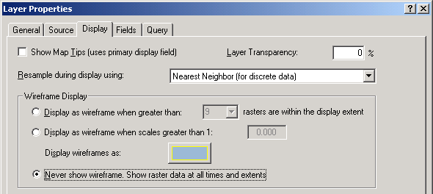
ArcMap HELP: The Color Orthos are Black & White!

Adding individual Color Orthos to ArcMap

In ArcMap, when you add data, click on the ortho ONLY ONCE and hit Add
(If you double-click & add the 3 bands, the image will display in Black & White)

DO:
1. Click ONLY ONCE
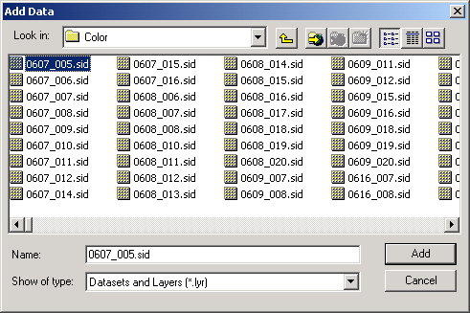
2. Click

DON’T:

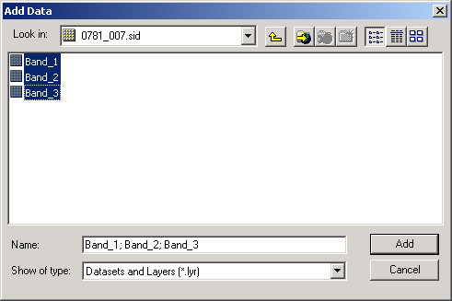
Layer file (.lyr) for Planning Jurisdictions

Layer files can be used in ArcMap to add data with a preset symbology.

***If you are NOT using ArcGIS you can ignore/delete the .lyr file.

***If you are using ArcMap you do not have to use the .lyr file. You can add the shapefile and symbolize it manually if you prefer.

If you are using ArcMap and you would like to use the .lyr file:
1. Unzip the jurisdiction shapefile to C:\gis\data
2. In ArcMap, add the .lyr using the ADD DATA button:

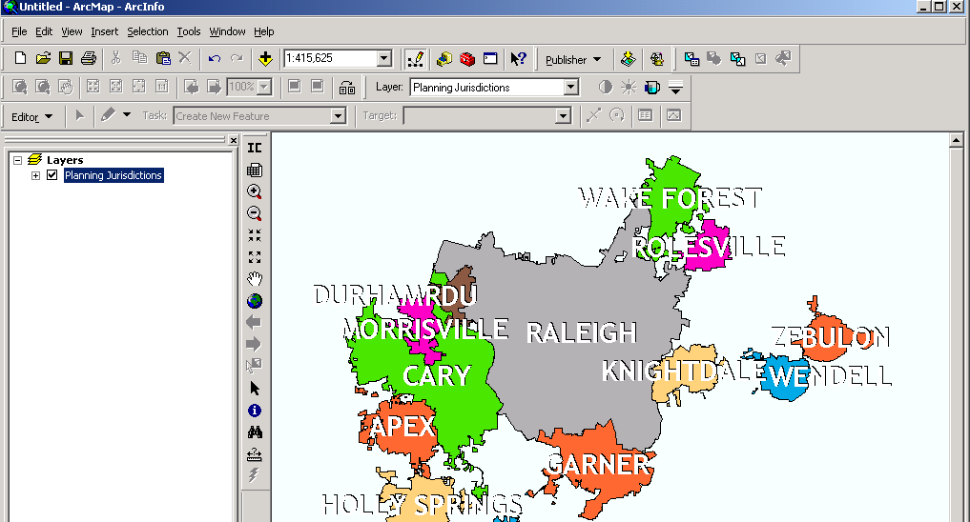

This will bring in the data with the symbology already defined.

Once you have brought the layer into ArcMap, you can then make changes to the symbology. For example you might want to change the color of the labels but leave the rest of the symbology as is. You will not affect the .lyr file by doing this. The .lyr file will not be changed unless you right-click on the data layer in the Table of Contents – Save As Layer File and overwrite the existing .lyr file.

If you want to store your data somewhere other than C:\gis\data, you can bring the .lyr file into ArcMap using the Add Data button (you will see a red exclamation point next to the layer indicating a broken path). Then Right-click on the name of the layer in the Table of Contents – Properties – Source and navigate to where you are storing the shapefile.
Viewing MrSIDS in ArcView 3.x

You may need to install a patch from LizardTech in order to view the orthos:
http://www.lizardtech.com/download/dl_download.php?detail=geo_avmrsid_dll&platform=win

Remember to turn on the Extension:

File – Extensions…

